**CAP785: WEB PERFORMANCE OPTIMIZATION**

**CONTINUOUS ASSESSMENTS (C.A)-3**

**ST_NAME : - EKHLAKH AHMAD**

**REG NO. : - 12209166**

**ROLL NO. : - 65**

**GROUP : - 2**

**WEB PAGE**

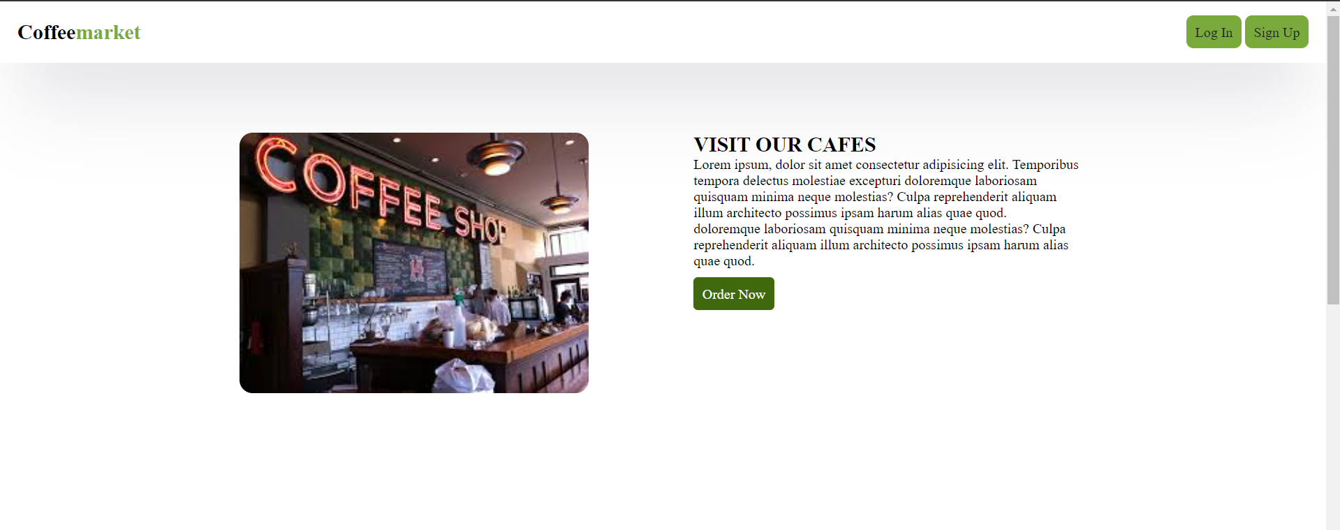

**HTML-CODE**

<!DOCTYPE html>

<html lang="en">

<head>

    <meta charset="UTF-8">

    <meta name="viewport" content="width=device-width, initial-scale=1.0">

    <title>Optimized Webpage</title>

    <link rel="stylesheet" href="style.css">

</head>

<body>

    <header>

        <h2><span class="coffee">Coffee</span><span class="market">market</span></h2>

        <div class="signin-up-btn">

            <a href="#">Log In</a>

            <a href="#">Sign Up</a>

        </div>

    </header>

    <div class="first-con">

        <div class="img-con">

            <img src="https://encrypted-tbn0.gstatic.com/images?q=tbn:ANd9GcS_LS39np_Un20zmRj5pFFDG49HyUVvIVdOL3lF3g8zrg&s" alt="">

        </div>

        <div class="text-con">

            <h2>VISIT OUR CAFES</h2>

            <p>Lorem ipsum, dolor sit amet consectetur adipisicing elit. Temporibus tempora delectus molestiae excepturi

                doloremque laboriosam quisquam minima neque molestias? Culpa reprehenderit aliquam illum architecto possimus

                ipsam harum alias quae quod. <br>

                doloremque laboriosam quisquam minima neque molestias? Culpa reprehenderit aliquam illum architecto possimus

                ipsam harum alias quae quod.</p>

            <a href="#">Order Now</a>

        </div>

    </div>

    <div class="first-con">

        <div class="text-con">

            <h2>VISIT OUR CAFES</h2>

            <p>Lorem ipsum, dolor sit amet consectetur adipisicing elit. Temporibus tempora delectus molestiae excepturi

                doloremque laboriosam quisquam minima neque molestias? Culpa reprehenderit aliquam illum architecto possimus

                ipsam harum alias quae quod. <br>

                doloremque laboriosam quisquam minima neque molestias? Culpa reprehenderit aliquam illum architecto possimus

                ipsam harum alias quae quod.</p>

            <a href="#">Order Now</a>

        </div>

        <div class="img-con">

            <img src="https://encrypted-tbn0.gstatic.com/images?q=tbn:ANd9GcQ5MkVTGHyBwnla0gVNTYbRbAIQqk6uSUUThWJG9aF1yA&s" alt="">

        </div>

    </div>

    <div class="first-con">

        <div class="img-con">

            <img src="https://assets.entrepreneur.com/content/3x2/2000/20190529191242-GettyImages-753289793.jpeg" alt="">

        </div>

        <div class="text-con">

            <h2>VISIT OUR CAFES</h2>

            <p>Lorem ipsum, dolor sit amet consectetur adipisicing elit. Temporibus tempora delectus molestiae excepturi

                doloremque laboriosam quisquam minima neque molestias? Culpa reprehenderit aliquam illum architecto possimus

                ipsam harum alias quae quod. <br>

                doloremque laboriosam quisquam minima neque molestias? Culpa reprehenderit aliquam illum architecto possimus

                ipsam harum alias quae quod.</p>

        </div>

    </div>

    <footer>

        <p>&copy; 2024 Optimized Webpage</p>

    </footer>

</body>

</html>

**CSS-CODE**

* {

    padding: 0;

    margin: 0;

    box-sizing: border-box;

    list-style-type: none;

    text-decoration: none;

}

@font-face {

    font-family: 'CustomFont';

    src: url('fonts/customfont.woff2') format('woff2'),

         url('fonts/customfont.woff') format('woff');

    font-weight: normal;

    font-style: normal;

}

header {

    width: 100%;

    height: 70px;

    background-color: rgb(255, 255, 255);

    display: flex;

    justify-content: space-between;

    align-items: center;

    padding: 10px 20px;

    box-shadow: rgba(50, 50, 93, 0.25) 0px 50px 100px -20px,

        rgba(0, 0, 0, 0.3) 0px 30px 60px -30px;

}

.coffee {

    color: black;

}

.market {

    color: #7aa93c;

}

header a {

    text-decoration: none;

    padding: 10px;

    background-color: #7aa93c;

    border-radius: 8px;

    color: #262626;

}

header a:hover {

    background-color: #80ba34;

}

.container {

    display: flex;

    flex-direction: column;

    justify-content: center;

    align-items: center;

    color: aliceblue;

}

.first-con {

    display: flex;

    justify-content: center;

    gap: 120px;

    padding: 80px 20px;

}

.img-con img {

    width: 400px;

    border-radius: 15px;

}

.text-con {

    width: 450px;

}

.text-con p {

    margin-bottom: 20px;

}

.text-con a {

    background-color: #40680d;

    padding: 10px;

    border-radius: 5px;

    color: white;

}

.gallary {

    display: flex;

    flex-wrap: wrap;

    justify-content: center;

    gap: 20px;

}

.content {

    width: 30%;

    margin: 10px auto;

    border: 1px solid gray;

    border-radius: 20px;

    padding: 10px;

}

.gallary img {

    width: 100%;

    object-fit: cover;

    border-radius: 20px;

}

footer {

    width: 100%;

    text-align: center;

    position: fixed;

    bottom: 0;

    background-color: #333;

    color: #fff;

    padding: 20px 0;

}

**PERFORMANCE**

